Grade 7 Accelerated · Unit 4 · Lesson 6  Order of Operations with Radicals  Question Bank 4.06 ANSWER KEY | Name  Date  Period

Show your work. Circle your final answer.
For questions 1 through 6, evaluate.
1. 
10
Multiply first, then left to right: 20 − 12 + 2.

2. 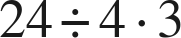
18
One level, left to right: 6 · 3.

3. 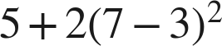
37
Parentheses, then the power, then the product: 5 + 2(16).

4. 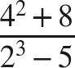
8
24 over 3.

5. 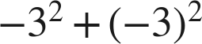
0
The first exponent is attached to the 3 alone; the second is attached to −3.

6. 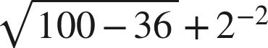

Under the bar first: 64, whose root is 8. Then 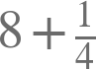.

For questions 7 and 8, evaluate. Each expression has more than one grouping symbol.
7. Evaluate each expression.
a. 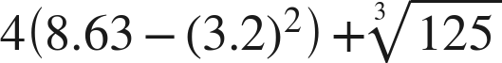
−1.44
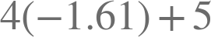.
b. 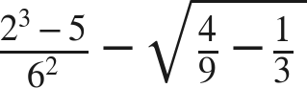
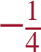
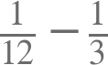.
c. 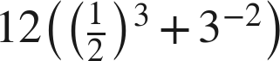

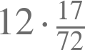. Written as 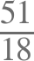 it is the same number.

8. Evaluate each expression.
a. 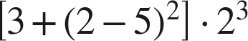
96
Innermost first: 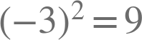, so the bracket is 12.
b. 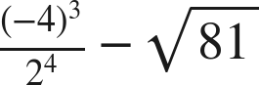
−13
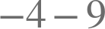.
c. 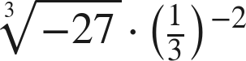
−27
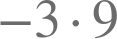.

Working backwards.
9. Find the value of that makes each statement true.
a. 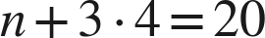
n = 8
b. 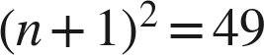, where is positive
n = 6
c. 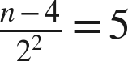
n = 24
.

Reading someone else's work.
10. Deshawn says that , because you always multiply before you divide. Is he right? Explain, and give the correct value.
He is not right. Multiplication and division are one level and are taken left to right, so  and then .
There is no rule that puts multiplication before division; the two share a level, and so do addition and subtraction.

11. Which is the value of 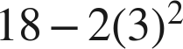 ?
○ A. 12
○ B. 144
○ C. −18
● D. 0
D

12. Select ALL of the expressions whose value is 4.
☐ A. 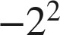
☒ B. 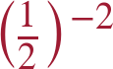
☒ C. 
☒ D. 
☒ E. 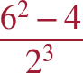
☐ F. 
B, C, D and E

